**State Management**



**Asynchronous Processing**

Cookies and Sessions Writing Concurrent Code in C#

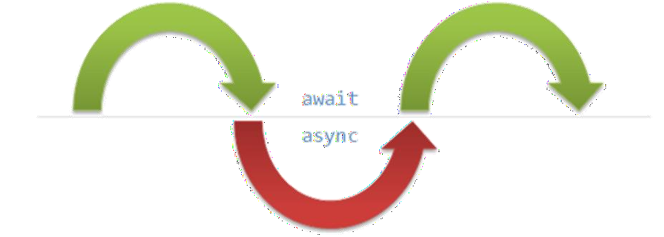

**SoftUni Team**

**Technical Trainers**

**Software University**

[**https://softuni.bg**](https://softuni.bg/)



**Table of Contents**

1. State Management
   * Cookies
   * Sessions



* + Session vs Cookies

1. Asynchronous Processing
   * Synchronous Programming
   * Asynchronous Programming
   * Threads
   * Tasks in C# (async and await)



**Have a Question?**

# sli.do



#csharp-web



## HTTP Cookies



#### Usages and Control

* A small file of plain text with no **executable code**
  + Sent by the server to the client's browser



* + **Stored** by the browser on the **client's device** (computer, tablet, etc.)
  + Hold small

piece of data for a **particular client** and a web site



**What Are Cookies?**



**What Are Cookies Used for?**

* Session management
  + Logins, shopping carts, game scores or anything else the server should remember



* Personalization
  + User preferences, themes and other custom settings
* Tracking
  + Recording and analyzing user behavior
* Breakfast
  + But that's not what we are currently talking about
* The HTTP object is **stateless**
  + It **doesn't store** information about the requests



Web Client



GET POST GET

Web Application



**Session Management**

 

Not stored



**Stateless HTTP – the Problem**

* The server **doesn't know** if two requests come from the same **client**

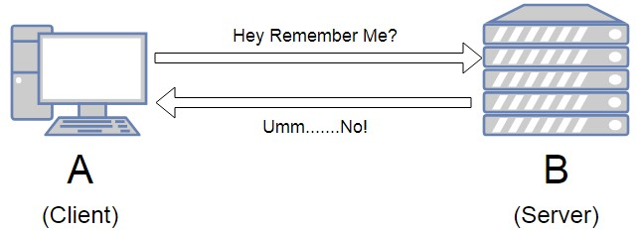

▪ State management problems

▪ **Navigation** through pages requires **authentication** each time

▪ **Information** about the pages is lost between the **requests**

▪ Harder **personalization** of functionality of pages

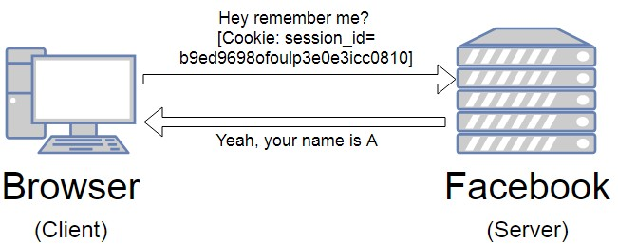

**Stateless HTTP – the Cookie Solution**

* A reliable mechanism for websites to remember **stateful information**



* + To know whether the **user** is

**logged** in or **not**

* + To know which account the **user is logged** in with
  + To record the user's **browsing activity**
  + To **remember** pieces of information **previously** entered into form fields (usernames, passwords, etc.)

### How Are Cookies Used?

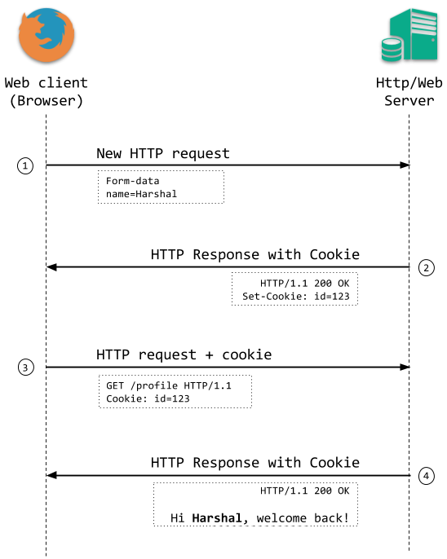

* The response holds the cookies to be saved within the **Set-Cookie** header



**HTTP/1.1 200 OK**

**Set-Cookie: lang=en**

* The request holds the specific web site cookie within the **Cookie** header

**GET** [**www.example.bg**](http://www.example.bg/) **HTTP/1.1 Cookie: lang=en**

Web Client



GET [www.example.bg](http://www.example.bg/) HTTP/1.1

Web Application



**Server-Client Cookies Exchange**

HTTP/1.1 200 OK Set-Cookie: lang=en

[**http://www.example.bg/**](http://www.example.bg/)



GET [www.example.bg](http://www.example.bg/) HTTP/1.1

Cookie: lang=en



**Cookie Structure**

* The cookie consists of **Name**, **Value** and **Attributes** (optional)
* The attributes are **key-value pairs** with additional information



* Attributes are **not included** in the **requests**
* Attributes are used by **the client** to control the **cookies**



Name=Value

Attributes

**Set-Cookie: SSID=Ap4P…GTEq; Domain=foo.com; Path=/;**

**Expires=Wed, 13 Jan 2021 22:23:01 GMT; Secure; HttpOnly**



**Scope**

* Defined by the attributes **Domain** and **Path**
* **Domain** – defines the website that the cookie belongs to



* **Path** – Indicates a **URL** path that must exist in the requested resource before sending the **Cookie** header

**Domain=foo.com; Path=/;**

**Set-Cookie: SSID=Ap4P…GTEq;**

**Expires=Wed, 13 Jan 2021 22:23:01 GMT; Secure; HttpOnly**

* Defined by the attributes **Expires** and **Max-Age**
* **Expires** – defines the date the browser should delete the cookie



* + By default

the cookies are deleted after the end of the session



**Lifetime**

* **Max-Age** – interval of seconds before the cookie is deleted

**Set-Cookie: SSID=Ap4P…GTEq; Domain=foo.com; Path=/;**

**Expires=Wed, 13 Jan 2021 22:23:01 GMT; Secure; HttpOnly**



**Security**

* Security flags do not have associated values
* **Secure** - tells the browser to use cookies only via



**secure/encrypted** connections

* **HttpOnly** – defines that the cookie cannot be accessed via client-side scripting languages

**Set-Cookie: SSID=Ap4P…GTEq; Domain=foo.com; Path=/;**

**Expires=Wed, 13 Jan 2021 22:23:01 GMT; Secure; HttpOnly**



**What is in the Cookie?**

* The cookie file contains a table with **key-value** pairs

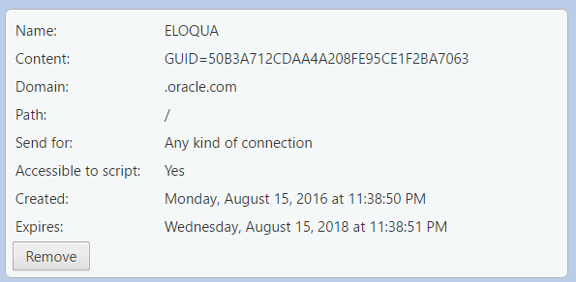





**Third Party Cookies**

* Cookies stored by an **external party** (different **domain**)
* Mainly used for advertising and tracking across the web

[**http://stackoverflow.com/**](http://stackoverflow.com/)



Cookie transfer

Web Application

Third Party

Web Client

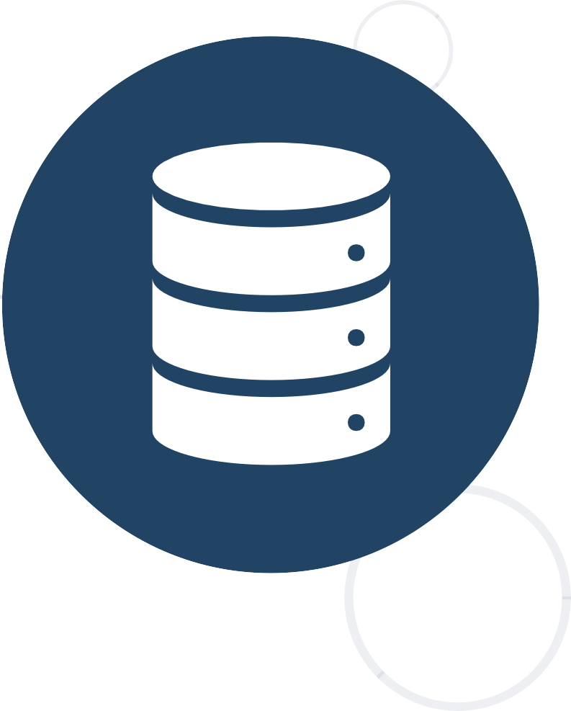

## HTTP Sessions

* A way to store information about a user to be used across

##### multiple pages



Web Application Session



**What Are Sessions?**





**user**: Teo

/login

/home

/products

* The exchange mechanism be used between the user and the web application

First Time Login



Web Client

User credentials

Web Application



**Session Management**

Session ID





* The exchange mechanism be used between the user and the web application



Browsing Pages

Web Client

Session ID

Web Application



**Session Management**

Requested data + Session ID







**Session Management**

* The exchange mechanism be used between the user and the web application

Browsing pages after



the server is restarted

Web Client Web Application

Session ID



Requested Data + Session ID



Session Store

**Cookie {** name: **sid** value: **5**

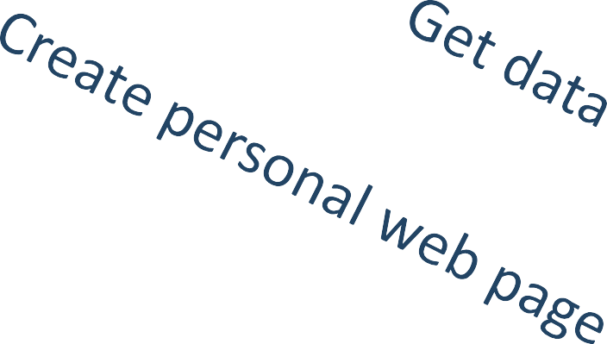

Web Application

Session

**sid 5 {**

**uid: 101**

**}**

**sid 7 {**

**uid: 102**

**}**

**}**

**Cookie {** name: **sid** value: **7**

Database

**}**



**Relation with Cookies**

**uid name 101 Teo**

**102 Bojo**

**Unique**

**"hje85d3"**

**"af354dd"**



**: {**

**user_id: 789 username: FirstUser**

**},**

**: {**

**Key-Value pairs**

**Session ID**

**user_id: 456**

**username: SecondUser**

**},**

**"fg78e5s" : {**

**user_id: 654**

**username: ThirdUser**

**with**

**user data**

**}**



**Session Structure**



## Session vs Cookies

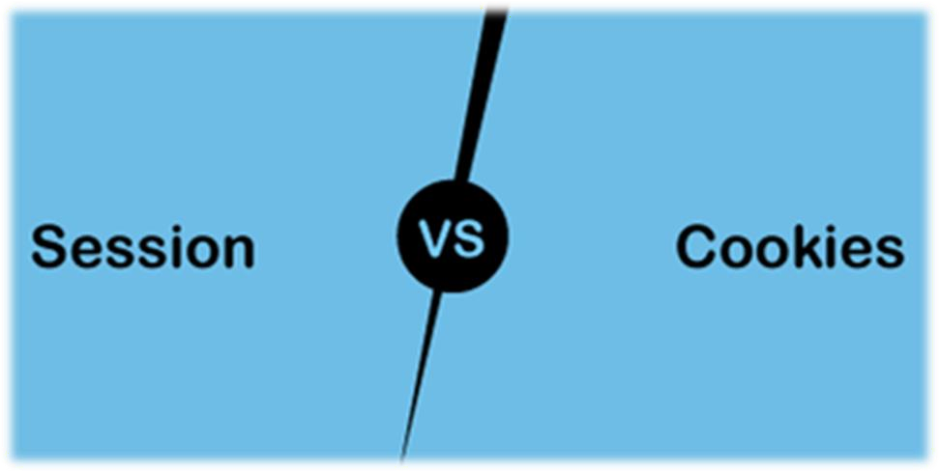

#### Differences and Usage

* **Session**
  + Stored on the server
  + Expires when the user closes the browser



* + It can store an unlimited amount of data
  + Depends on the cookie
  + Secure –saves data in encrypted form and cannot be accessed by anyone easy
* **Cookies**
  + Stored on the user's computer as a text file
  + Expires on its expiration date
  + It can store only limited data
  + Does not depend on the session
  + Have security issues, as data is stored in a text file and it can be accessed by anyone easily



**Session vs Cookies**



26



## Synchronous Programming

#### Benefits and Drawbacks



**Synchronous Programming**

* Executing program components **sequentially**
  + "Sequential programming"



* + 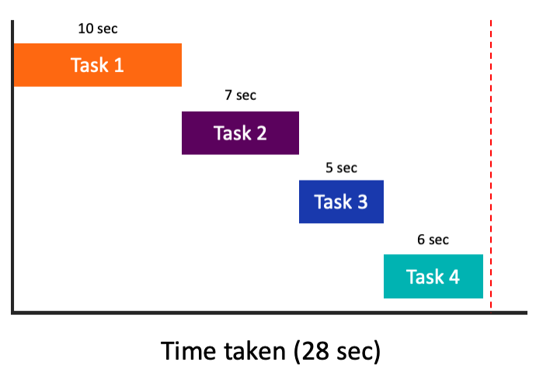Actions happen one after another
* Components **wait** for previous components to finish
* Program resources are accessible at all points
* Synchronous code is executed **step by step**



**int n = int.Parse(..)**

**static void Main()**

**{**

**int n = int.Parse(Console.ReadLine()); PrintNumbersInRange(0, 10); Console.WriteLine("Done.");**

**PrintNumbersInRange()**

**}**

**static void PrintNumbersInRange(int a, int b)**



**Synchronous Code**

**{**

**for (int i = a; i <= b; i++)**

**{**

**Console.WriteLine(i);**

**}**

**}**

**Console.WriteLine(..)**

**...**

**Console.Write("Enter your name: "); string name = Console.ReadLine();**



**Synchronous Code – Long Running Operation**

**for (int i = 0; i < int.MaxValue; i++)**

**{**

**// Execute some operations here**

**}**

**Console.WriteLine($"Hello, {name}!");**

**You will have to wait for the long- running operation to finish before you can see the greeting**



**Synchronous Programming Drawbacks**

* If one **component is blocked**, the **entire program is blocked**
* UI may become **unresponsive**



* No utilization of multi-core systems
* CPU-demanding tasks **delay execution** of all other tasks
* **Accessing resources** blocks entire program
  + Especially problematic with web resources



## Asynchronous Programming

#### Benefits and Drawbacks



**Asynchronous Programming**

* Program components can execute in **parallel**

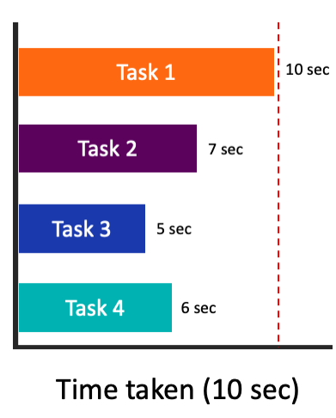

* + Some actions run alongside other actions



* + Each action can happen in a **separate** thread
* **Independent** components don't wait for each other
* Program resources shared between threads
  + If one thread uses a resources, others shouldn't use it

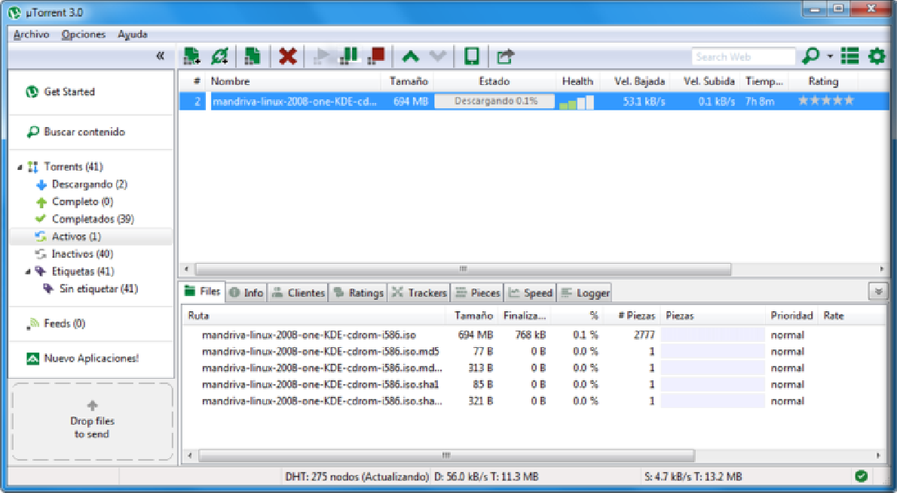

**Asynchronous Programming – Benefits**

* If a component is blocked, other

##### components still run



* + UI runs separately and always remains responsive
* Utilization of multi-core systems
  + Each core executes **one or more** threads
* CPU-demanding tasks run on "**background**" threads
* Resource access runs on "**background**" threads
* Hard to know which code parts are running at a specific time

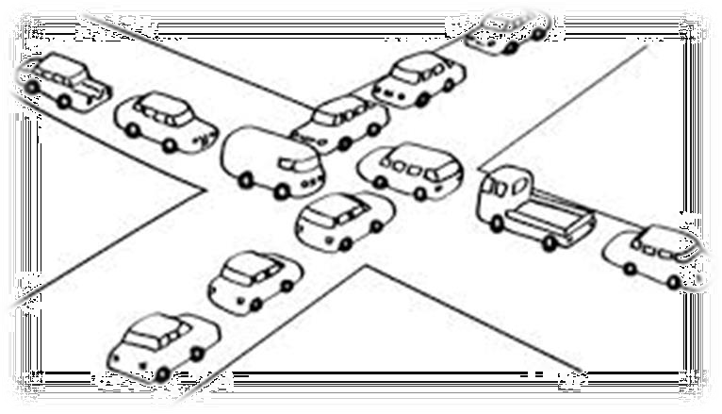

* Harder than



usual to **debug**



**Asynchronous Programming – Drawbacks**

* Have to **protect resources**
  + One thread uses a resource
  + Other threads must wait for the resource
* **Hard to synchronize** resource access
  + **Deadlocks** can occur
* Asynchronous programming allows the execution of code

##### simultaneously



**int n = int.Parse(Console.ReadLine());**

**PrintNumbersInRange(0, 100);**

**int n = int.Parse(..)**

**var task = Task.Run(() =>**

**PrintNumbersInRange(100, 200));**

**for**

**(0..100)**

**Console.WriteLine("Done."); task.Wait();**



**Asynchronous Code**

**Console.WriteLine(…)**

**Wait()**

**for (100..200)**



## Threads

#### Call Stack, Thread-Safety, Exception Handling

* Each program's code is translated to CPU instructions

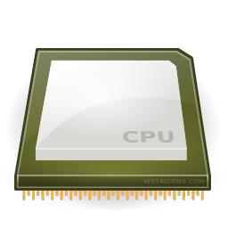

**Program.cs**



**int a = 5; int b = 4;**

**Console.WriteLine(a + b);**

**Program.exe**

**Instructions are executed one by one**

Compilation

Single-Core CPU



**Instruction Execution**

|  |  |  |  |  |
| --- | --- | --- | --- | --- |
| **00DA2655** | **mov** | **dword** | **ptr** | **[ebp-40h],5** |
| **00DA265C** | **mov** | **dword** | **ptr** | **[ebp-44h],4** |
| **00DA2663** | **mov** | **ecx,dword** | | **ptr [ebp-40h]** |
| **00DA2666** | **add** | **ecx,dword** | | **ptr [ebp-44h]** |
| **00DA2669** | **call** | **73B5A920** | |  |
| **00DA266E** | **nop** |  | |  |

* A computer

can run **many processes** (applications) at once



**Multi-Tasking**

* + But each CPU core can only execute one instruction at a time



* + **Parellelism** is achieved by the operating system's **scheduler**
    - Grants each **thread** a small interval of time to run



**0 5 10 15 20 25 ms**

**...**

**program.exe**

**system.exe**

**winamp.exe**

**chrome.exe**

**program.exe**

* A **thread** is a fundamental unit of code execution
* Commonly, processes (programs) use more than one thread



* + In .NET, there is always more than one thread (e.g. GC)
* Each thread

has a **memory area** associated with it known

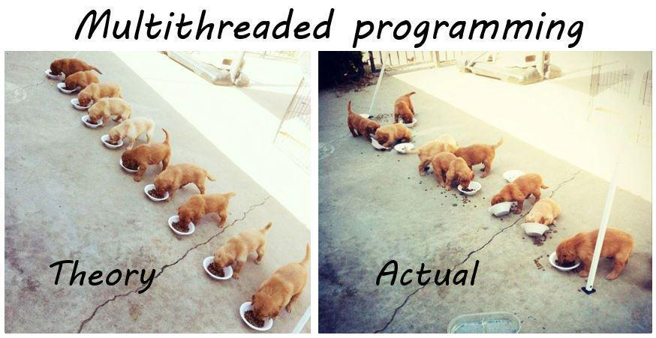as a **Call Stack**



**Threads**

* + Stores **local variables**
  + Stores the **currently invoked methods**

in order of invocation



**Threads in C#**

* Threads in C# can be created using the **System.Thread** class
* Constructor accepts a **method** (delegate) to execute on a separate thread



**Thread thread = new Thread(() =>**

**{**

**for (int i = 0; i < 10; i++)**

**{**

**Console.WriteLine(i);**

**}**

**});**



**System.Thread**

* **Start()** – schedules the thread for execution
* **Join()** – waits for the thread to finish its work (blocks the calling thread)



**Thread primes = new Thread(() => PrintPrimesInRange(1, 10000));**

**primes.Start();**

**Console.WriteLine("Waiting for thread to finish work..."); primes.Join();**

**Thread – Example**

**List<long> numbers = new List<long>(); Thread t = new Thread(() =>**

**SumOddNumbers(numbers, 10, 100000000L)); t.Start();**

**Console.WriteLine("What should I do?"); while (true)**

**{**

**string command = Console.ReadLine(); if (command == "exit") break;**

**}**

**Console interface**

**t.Join();**



**remains unblocked**

* Each thread has its own **stack**
  + The start (bottom) of the stack is the method from which the thread began execution



|  |
| --- |
| ch method (frame) stor |
| **...** |
| **IsPrime()** |
| **PrintAllPrimes()** |
| **Main()** |
| main thread |

* + Ea



**Thread Stack**

es local variables

|  |
| --- |
| **...** |
| **IsValidUrl** |
| **DownloadAsync** |

background thread



**Thread Race Conditions**

* A **race condition** occurs when two or more threads access shared data and they try to change it at the same time

**List<int> numbers = Enumerable.Range(0, 10000).ToList(); for (int i = 0; i < 4; i++)**



**{**

**new Thread(() =>**

**{**

**while (numbers.Count > 0) numbers.RemoveAt(numbers.Count - 1);**

**}).Start();**

**}**



**Thread Safety**

* A thread-safe resource can be safely accessed by multiple threads



* **lock** keyword grants access to only one thread at a time
  + Avoids race conditions
  + Blocks any other threads until the lock is released



**lock (numbers)**

**{**

**if (numbers.Count == 0) break;**

**int lastIndex = numbers.Count - 1; numbers.RemoveAt(lastIndex);**

**}**



**Exception Handling**

* Exceptions cannot be handled outside a thread



**try**

**{**

**new Thread(DoWork).Start();**

**}**

**catch (Exception ex)**

**{**

**Console.WriteLine("Exception!");**

**}**

**This part will never be reached**

**public static void DoWork()**

**{**

**throw new ArgumentNullException();**

**}**

### Exception Handling – the Right Way

**new Thread(DoWork).Start();**

**public static void DoWork()**

**{**

**try**

**{**

**throw new ArgumentNullException();**

**Exceptions should be**

**} handled**

**inside the**

**catch (Exception ex)**

**{**

**executed method(s)**

**Console.WriteLine("Exception handled!");**



**}**

**}**

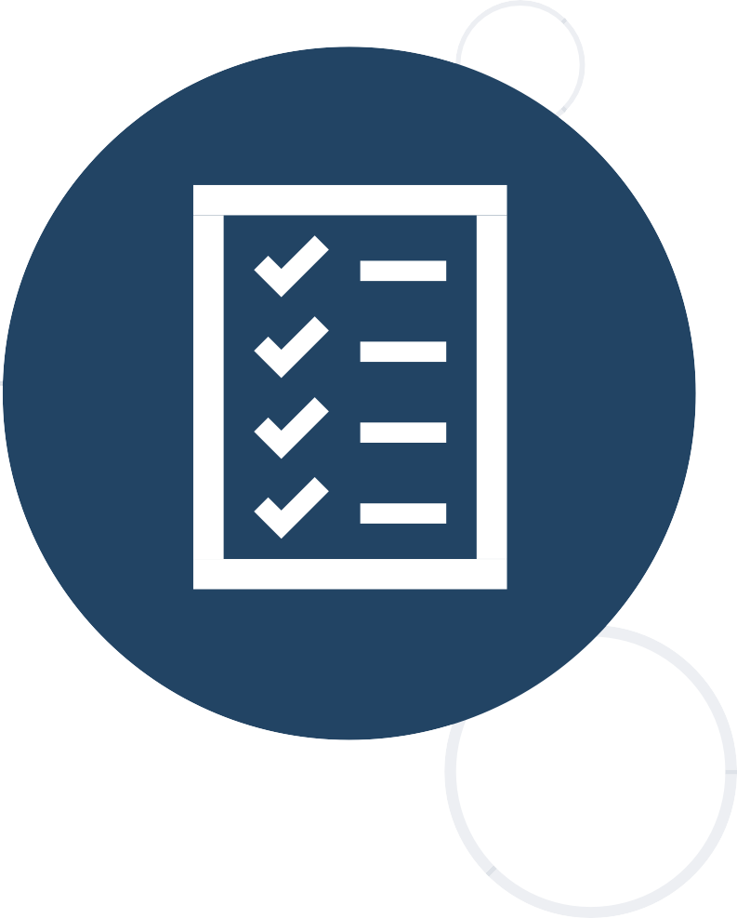

## Tasks in C#

#### Task Parallel Library



**Tasks in C#**

* 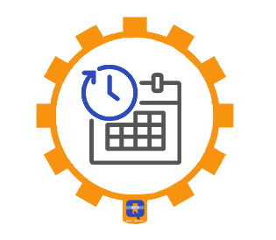A task is a high-level representation of concurrent work
  + Runs in **parallel** with the main thread



* + May not run on a new thread (the CLR decides)
  + Offers several operations
    - Creating, running and **returning** result
    - Continuing with another task (**chaining several operations**)
    - Proper exception handling
    - Progress/state reports



**Creating Tasks in C#**

* Creating tasks can be done in several ways



* Initialize a new **Task** object

**Task task = new Task(() => { Console.WriteLine(""); });**

* + **Task.Run()**

**Task.Run(() => TraverseMatrix());**

* + **Task.Factory.StartNew()** – enables additional task customization

**Task.Factory.StartNew(() => CopyFileContents("got-s03ep1.avi"),**

**TaskCreationOptions.LongRunning);**

* **Task<T>** is a task that will return a result sometime in the future



**Task<long> task = Task<long>.Run(() =>**

**{**

**long sum = 0;**

**for (int i = 0; i < 10000; i++) sum += i; return sum;**

**});**

**Console.WriteLine(task.Result);**



**Generic Tasks**

**Blocks the calling thread until the task returns a result**

* **Exceptions** that have occurred within the body of a **Task** can be captured and handled outside of it



**var task = SliceAsync(VideoPath, DestinationPath, 5); try**

**{**

**task.Wait();**



**Task Exception Handling**

**}**

**catch (AggregateException ex)**

**{**

***// Handle exception...***

**}**

**You can use the AggregateException to wrap all exceptions thrown by different threads**



## Async and Await

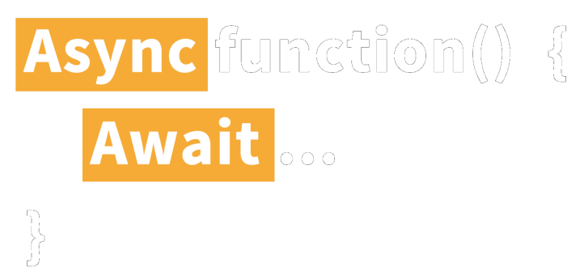

#### Keywords for Asynchronous Operations



**Tasks with Async and Await (1)**

* The keywords **async** and **await** are **always** used together
* **async** hints the compiler that the method might run in parallel



* + Does not make a method run asynchronously (**await** makes it)

**static async void SliceFileAsync(string file, int parts)**

* + Tells the compiler "**this method could wait for a resource or operation**"
    - If it starts waiting, return to the calling method
    - When the wait is over, go back to called method
* **await** is used in a method which has the **async** keyword
  + Saves the context in a state machine



* + Marks waiting for a resource (a task to complete)
    - Resource should be a **Task<T>**
    - Returns

**T** result from **Task<T>** when it completes



**Tasks with Async and Await (2)**

**await DownloadStringAsync("https://softuni.org");**

**Returns Task<string>**

**Async and Await – Example**

**static void Main()**

**{**

**DownloadFileAsync(File Url, "book.pdf");**

***// Do some other work***

**After the method is over the calling thread gets**

**back to the calling method**

**}**

**static async void DownloadFileAsync(string url, string fileName)**

**{**

**Console.WriteLine("Downloading...");**

**await Task.Run(() =>**

**{**

***// Download the file***

**});**

**The calling thread exits the method on await**

**When the waiting is over, the calling thread proceeds with**

**Console.WriteLine("Download successful.");**



**}**

**method execution**

### Summary



* + **State management**
    - **Cookies** are client based stored information
    - **Sessions** are server-based information
  + **Asynchronous processing**
    - **A thread is a unit of code execution**
    - **Multithreading**
    - **Tasks facilitate the work with multithreading**
      * **async and await keywords**





# A picture containing text, sign, vector graphics Description automatically generatedQuestions?







**SoftUni Diamond Partners**







**Educational Partners**



**Trainings @ Software University (SoftUni)**

* Software University – High-Quality Education, Profession and Job for Software Developers



* + [softuni.bg](https://softuni.bg/), [about.softuni.bg](https://about.softuni.bg/)



* Software University Foundation
  + [softuni.foundation](https://softuni.foundation/)
* Software University @ Facebook
  + [facebook.com/SoftwareUniversity](https://www.facebook.com/SoftwareUniversity)
* Software University Forums
  + [forum.softuni.bg](https://forum.softuni.bg/)



**License**

* This course (slides, examples, demos, exercises, homework,

documents, videos and other assets) is **copyrighted content**



* Unauthorized copy, reproduction or use is illegal
* © SoftUni – [https://about.softuni.bg](https://about.softuni.bg/)
* © Software University – [https://softuni.bg](https://softuni.bg/)